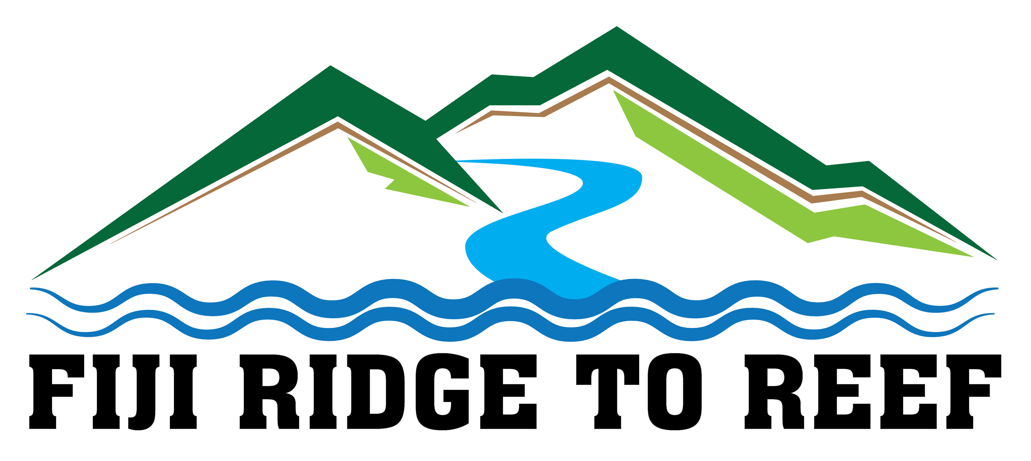

**The Institute of Applied Sciences**

**Fiji Ridge to Reef Project**

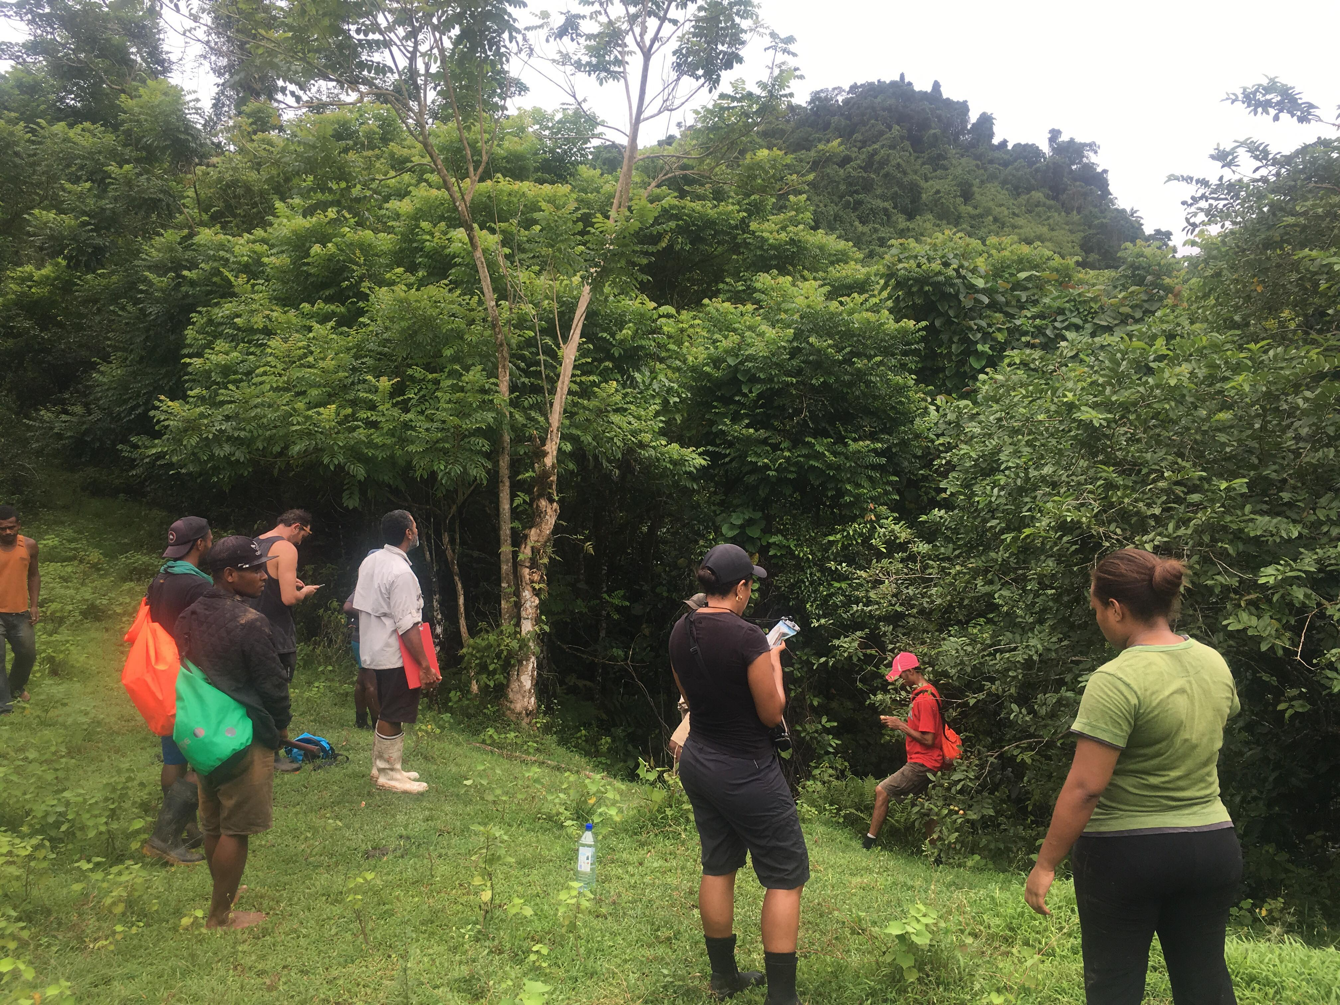**SUMMARY REPORT   
Reporting Period: 1 April to 30 June, 2019**

June 2019

This document was prepared by the Institute of Applied Sciences of the University of the South Pacific for the Fiji Ridge to Reef (R2R) Project. **This project is funded by the Global Environment Facility.**

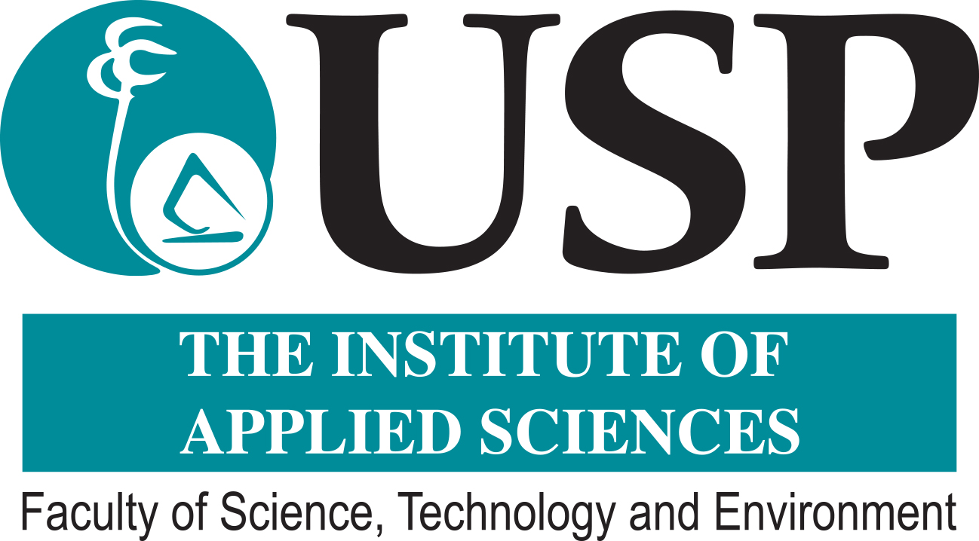

**The Institute of Applied Sciences**

**Fiji Ridge to Reef Project**

**QUARTERLY REPORT   
Reporting Period: 1 April to 30 June, 2019**

Cover photo – USP-IAS staff conduct reconnaissance and capacity building activities at Waibasaga in Naitasiri Province

Contents

List of Acronyms and Abbreviations 4

1. ACTIVITIES AND MILESTONES 5

1.1 Activity and Milestones Reports 5

2. COMMUNICATIONS AND OUTREACH 10

2.1 Website and Social Media Platforms 10

2.2 Mainstream Media 10

2.3 Outreach 10

3. GENDER 10

3.1 Gender Plan 11

3.2 Activity Reports 11

4. ORGANIZATION CAPACITY 12

4.1. Internal Capacity Building 12

4.2. External Capacity Building 12

5. KEY ACHIEVEMENTS AND SUCCESSES 13

6. CHALLENGES FACED AND CORRECTIVE ACTIONS TAKEN 14

7. USP-IAS ACTIVITIES AND MILESTONES FOR QUARTER 3 2019 15

List of Acronyms and Abbreviations

|  |  |
| --- | --- |
|  |  |
| BOS | Bureau of Statistics |
| C3 | Community Centered Conservation |
| CPUE | Catch Per Unit Effort |
| DFO | Divisional Fisheries/Forestry Officer |
| FELA | Fiji Environmental Law Association |
| FLMMA | Fiji Locally Managed Marine Areas (Network) |
| IAS | The Institute of Applied Sciences (USP) |
| IBA | Important Bird Area |
| IMR | The Institute of Marine Resources (USP) |
| ITTO | The International Tropical Timber Organization |
| LMMA | Locally Managed Marine Areas |
| LoA | Letter of Agreement |
| MACBIO | Marine and Coastal Biodiversity Management in Pacific Island Countries |
| MMA | Marine Managed Area |
| MOE-PMU | Ministry of Environment - Project Management Unit |
| MPA | Marine Protected Area |
| NFMV | Nature Fiji Mareqeti Viti |
| PCO | Provincial Conservation Officer |
| QMC | Quality, Marketing and Communications Unit (USP-IAS) |
| R2R | Ridge to Reef |
| SMS | School of Marine Studies (USP) |
| SPRH | South Pacific Regional Herbarium (USP-IAS) |
| UNDP | United Nations Development Program |
| USP | The University of the South Pacific |
| WWF | World Wildlife Fund |
|  |  |
|  |  |
|  |  |
|  |  |
|  |  |

# ACTIVITIES AND MILESTONES

*The sections below report on activities and milestones completed this quarter.*

## 1.1 Activity and Milestones Reports

**Activity 1.1.1.2:** Ministry of Fisheries (R2R) support to *Vanua o Votua iqoliqoli* committee to review current community conservation action plan and marine protected areas (LMMA and tabu areas) connected with Ba River.

**USP-IAS sub-activity:** Marine biological surveys and CPUE to identify and delineate proposed community MMA’s.

Progress (ongoing): A CPUE census was conducted in Votua, Ba as owners of the Qoliqoli Votua. The CPUE report will be submitted in August 2019 as a milestone deliverable for this quarter. Fieldwork for the shark and ray survey was also completed in the quarter. The report will be submitted in August 2019 too. The remaining marine biological survey that was initially planned for April 2019 has now been deferred to September/October 2019. This biological survey is in collaboration with the Ministry of Fisheries and WWF as was agreed to in the gap analysis workshop in December 2018 (refer workshop report of December 2018).

Milestone: CPUE Census Report; Shark and Ray Survey Report

**Activity 1.1.1.3:** Ba River (freshwater) qoliqoli to develop management plan and implement and lobby for required actions and practices to restore freshwater fisheries (including especially prawn, kai and finfish).

**USP-IAS sub-activity:** Freshwater baseline survey with three specific indicators – species, water quality and sedimentation.

Progress (ongoing): In Quarter 2 2019 USP-IAS completed the following:

1. Water quality and sedimentation sampling.
2. All lab analysis and data entries.
3. Reports as follows will be submitted in August 2019. They are at the final stages of review:
   1. Ba Mangrove Nekton Survey Report
   2. Ba River Invertebrate and Vertebrate Report
   3. Ba River Water Quality and Sedimentation Report

The freshwater clam survey is continuing into the third quarter given unexpected natural extremities when the first survey was conducted in June. Currents were really strong over the study period and divers were unable to complete transacts for safety reasons. A second visit is being planned for August 2019 with the report scheduled to be submitted in September 2019.

Milestones:

1. Ba Mangrove Nekton Survey Report
2. Ba River Invertebrate and Vertebrate Report
3. Ba River Water Quality and Sedimentation Report

**Activity 1.1.1.4:** Ministry of Fisheries (R2R) support to Macuata Cokovata *qoliqoli* committee and *qoliqoli* owners of Vanua Labasa and Wailevu to develop/review /confirm better plan location of MPA (LMMA & tabu areas) connected with Labasa River.

**USP-IAS sub-activity:** Marine biological survey and CPUE to identify and delineate proposed community MMA’s.

Progress (ongoing): A marine planning workshop was held for all catchments in Quarter 2 2019 with the endorsement of the Ministry of Environment. Including plans for all catchments was thought of as the most cost effective process as most participants, bar the YMST and Provincial Office representatives, were the same implementers across all catchments. As such, this workshop was co-facilitated by the Ministry of Fisheries and USP-IAS. The outcomes were clear work plans and agreed methodologies to be used across all catchments with proper allocation of tasks for each of the catchments. The workshop report will be submitted in August 2019 as the milestone for this quarter.

Milestone: Marine Planning Workshop Report

**Activity 1.1.1.7:** Undertake negotiations with eleven *mataqali’s* involving NFMV, R2R/DoE, TLTB, TAB and NTF, to confirm interest to formalize existing terrestrial Protected Area in Tunuloa catchment (Year 1).

Progress (completed): USP-IAS, NFMV and relevant Government Ministries co-implementing this activity. The activities have been completed this quarter with the consultation with the eleven landowning mataqali’s. Consultations were carried out from 3-12 April 2019. The consultation report will be submitted in August as the final output from this activity. It will contain maps of the IBA area and the encroached upon areas from community mapping exercises. These encroachments are the result of leases and other community land uses over the years. The full discussion of these and recommendation will be in the final report.

Milestone: Report of the consultations with the eleven mataqali’s of Natewa-Tunuloa.

**Activity 1.1.2.11:** Comprehensive BIORAP survey of site for a new Tuva PA (located in upper Tuva catchment and adjacent part of upper Nadi catchment, Vunamoli mataqali), to be conducted by USP IAS in Year 1.

Progress (ongoing): The Tuva BioRap fieldwork was completed this quarter. The reconnaissance survey was conducted from the 14-17 April to finalise planning and logistics with the local communities and relevant stakeholders. The actual BIORAP survey was conducted in three phases beginning the 29th of April with the Upper Tuva areas. The second phase started on the 6th of May at the Lower Tuva areas with a final phase 3 trip to the cloud forests of Mount Koroba from 25 June. The final report is still scheduled to be submitted at the end of August 2019. This will contain maps of all study areas within the catchment.

Milestone: Fieldwork, lab and data analysis and data entry completed.

**Activity 2.1.1.14:** Identify areas in need of reforestation notably wastelands of African tulip and degraded open secondary forests: this activity to be undertaken through collaboration of DoF and landowners in Year 1.

Progress (ongoing): The National Trust of Fiji led African tulip wasteland survey in four villages in the Waidina area, which are Delailasakau, Nasevou, Nadukuni and Naivucini, was completed this quarter.

The joint team from USP-IAS and NTF conducted three surveys over the period and they were joined by Ratu Mika Seruitukana from Delailasakau village, who is also the Chairman of the Sovi Landowners Committee. African tulip wastelands in the area were marked out and these was presented to the Ministry of Forests and MOE PMU. Because Activity 2.1.1.14 is a precursor to Activity 2.1.1.15 and further on the development of a reforestation plan for Waidina, it is crucial that relevant implementers are aware of what the others are doing. An outcome of the meeting at USP-IAS was that USP-IAS and NTF could go ahead and carry out African tulip eradication and rehabilitation work in the buffer zones of the Sovi Basin and do not need to await the reforestation plan. We will seek written confirmation of this before we proceed. The final activity report will be submitted at the end of August 2019.

Milestone: African tulip wastelands has been mapped.

**Activity 2.1.1.19:** Undertake once-off stand improvement activities in secondary forests (at a rate of 50 ha per year in Years 2, 3 and 4), including removal/cutting of African tulip and cutting of overtopping vines – wadamu (*Merremia peltata*). The selected forests will be those which are in reasonably good condition and preferably located in buffer zones for Sovi Basin Protected Area (within 5-10 km), with the stand improvement to be undertaken by Nadakuni villagers.

Progress (moved to Quarter 3 2019): In a meeting with the National Trust of Fiji (NTF) on 29th February 2019 on work to be conducted by USP-IAS in Waidina, the NTF registered their interest in collaborating with USP-IAS on this Activity. It was agreed though, that this Activity should follow the identification of African tulip wastelands (Activity 2.1.1.14) as it will clearly demarcate areas for rehabilitation. Now that the wastelands have been identified, we will seek the help of the PMU, the Ministry of Forests and UNDP that USP-IAS (in collaboration with the National Trust of Fiji) can go ahead and carry out rehabilitation in the buffer zones of the Sovi Basin. Please refer to comments for the same Activity in Section 7 of this report.

Milestone: There were no activities in Quarter 2 2019.

**Activity 2.1.1.21:** Establish 10 ha of mangrove demonstration stands per year in years 2, 3 and 4.

Progress (ongoing): USP-IAS is leading this activity. Another stakeholder meeting was held in the second quarter to discuss lessons learnt from the ITTO Project and get advice from the R2R NGO rep. The key deliverables for Quarter 2 2019 was planning, recon and site selection and community consultations, particularly in the Tailevu Province. A second mangrove nursery was set up at Nakalawaca in the District of Namara, Tailevu. The total mangrove seedlings established so far is 3,222 (1,722 in Nukui and 1,500 in Nakalawaca). The community consultations held so far has provided us with key information on the species of tree seedlings the communities would prefer and the types of area that needs rehabilitation. However, the communities and the Rewa and Tailevu Provincial Offices will now work to ensure that mataqali’s who own the lands earmarked for rehabilitation agree to it first. USP-IAS will await instructions from the Provincial Offices before mapping the planting area. As such, we cannot provide at this stage the total area to be planted. In the meantime, we’ve agreed with the ITTO Project that USP-IAS will begin storing seedlings in the Ministry of Forests distribution nurseries in Rewa and Tailevu. The target is 5,000 seedlings in Quarter 3, 2019. Our collaborators include the Ministry of Forests, Ministry of Fisheries, Ministry of Agriculture, Ministry of Environment and the Rewa and Tailevu Provincial Offices. The collaborative effort is truly commendable and testament of this is the participation of all partners in all phases of activities.

Milestone: None over the period.

**Activity 2.2.3.4:** DoF in association with research partners (including Southern Cross University/ACIAR, SPC) establish sample plots, annually measure and reports on growth, survival and carbon sequestration in reforestation plantings of enrichment plantings, and impact of stand improvement activities.

**USP-IAS Sites:** Tuva and Waidina

Progress (ongoing): In Quarter 2 2019 the only activities carried out were soil sample processing in our laboratory. Soil samples were collected in Quarter 1 2019 and they are ready for data analysis. This process will take place in August when our Carbon specialist comes in for Phase 2 of the training. We have in collaboration with our consultants developed draft methodologies for both Waidina and Tuva and these are attached. Please note that we are submitting them in PDF deliberately as they are still in draft and yet to be presented to the Ministry of Forests. We request that these not be shared until they have endorsed it. The process of its endorsement will begin from 5-8 August 2019 through a number of meetings with the Research Division and the REDD+ Unit.

Milestone: Methodologies drafted.

**Activity 3.1.1.2:** Demographic and socioeconomic data for the R2R catchments reviewed and refined by Ministry of Strategic Planning/ Bureau of Statistics as input into catchment management plans – (2nd Quarter, Year 1).

**USP-IAS Sites:** Tuva, Waidina-Rewa, Vunivia and Tunuloa

Progress (ongoing): USP-IAS have had a meeting with the Chairman of the Nadroga Provincial Office and have contacted Provincial and Divisional Offices in all three catchments in an attempt to extract relevant data from these catchments. Data is scattered and in some instances in its raw form and cannot be shared with us. Do note that we have exhausted the budget for this activity but with the authority of our Acting Director, we will complete the tasks at USP-IAS’s expense. These additional expenses will be recorded and put forth as in-kind contribution to the R2R Project.

Milestone: Socioeconomic and demographic data analysis report for Tuva will be submitted in August 2019, followed by the Vunivia and Tunuloa reports in September 2019.

**Activity 3.1.1.3:** Survey outcomes and biophysical and demographic studies is made available to communities /stakeholders for information and to assist with formulation of management plans (Year 1)

**USP-IAS Sites:** Tuva, Waidina-Rewa, Vunivia and Tunuloa

Progress (ongoing): The Waidina-Rewa catchment surveys were conducted in this quarter beginning from 6 May 2019 in the Rewa Province. A team of eight enumerators from USP-IAS were trained and surveyed a total of fourteen villages over three weeks. The final report is being collated and will be submitted at the end of August 2019.

Milestone: Waidina-Rewa survey report.

# COMMUNICATIONS AND OUTREACH

*These are the communication and outreach activities conducted over the reporting period.*

## 2.1 Website and Social Media Platforms

* 1. USP-IAS’s Facebook page continues to highlight our on-ground activities. Some posts have been shared by UNDP onto their page and we are getting positive feedback with increasing views on these posts. We continue to acknowledge the funding by GEF and UNDP and the Fijian Government through the Ministry of Environment as implementers. The MOE PMU team also requested interviews from one of our sites and a trip was organized to Nakalawaca, Namara, Tailevu with the MOE PMU team to capture some stories. The material (interview and photos) are with the MOE PMU.

## 2.2 Mainstream Media

1. USP-IAS did not engage with any media organizations in the Quarter. However, earmarked for Quarter 3 2019 is a UNDP and Ministry of Environment high-level mangrove-transplanting event at the Nukui, Rewa mangrove rehabilitation site. This is scheduled for the end of August 2019. USP-IAS will require the exact date for the planned event from UNDP/MOE at the earliest so it can inform the community accordingly.

## 2.3 Outreach

Progress (ongoing): There were a number of joint outreach programs organized in coordination with the MOE-PMU and various Government Ministries. These included the upper and lower Tuva BioRap’s, collaboration on the consultations with the 11 mataqali’s of Natewa and the wasteland mapping with the National Trust of Fiji in Waidina. We have also met with the Director Research at the Ministry of Forests and the REDD+ team concerning our carbon stock assessments in Tuva and Waidina and the Activity 2.1.1.14-2.1.1.19 activities.

# GENDER

*Activities conducted to address issues identified in our Gender Analysis and Gender Action Plan include the activities, location, audience, outcomes and next steps where appropriate.*

## 3.1 Gender Plan

Over the duration of the quarter, we had ensured that women and youth were represented in our community consultations and fieldwork.

## 3.2 Activity Reports

**Activity 1.1.1.2 and 1.1.1.4**

Progress (ongoing): These activities are being led by Rosemary Dautei, USP-IAS’s Marine Projects Officer. In her team are Technical Officer Mere Vere who assists with logistics and research and Gandercillar Wainiqolo who was replaced by Adi Vasiti Soko as the GIS Officer.

**Activity 1.1.1.3**

Progress (ongoing): Rosemary Dautei is support scientist on the freshwater clam survey. A local female guide was engaged over the duration of this same survey.

**Activity 1.1.1.7**

Progress (ongoing): The joint USP-IAS/NFMV/MOE lead team consists of three females, Nunia Moko, Siteri Tikoca of NFMV and MOE PMU North Project Officer Jacqueline Seru. Women and youth also attended and their input was captured during the mataqali consultations in Natewa-Tunuloa.

**Activity 2.1.1.14**

Progress (ongoing): This is a collaboration with the National Trust of Fiji which is led by Elizabeth Erasito and assisted by Lavenia Taura. Mapping was done by Kasaqa Tora (NTF) and Adi Vasiti Soko (USP-IAS). Ground truthing consultations included women and youth of the villages.

**Activity 2.1.1.21**

Progress (ongoing): The nursery setup in Nakalawaca, Tailevu included females from their youth group. Our team collaborates closely with Raijieli Kolinisau and Talei Kocovanua, the PCO’s Rewa and Tailevu respectively.

**Activity 2.2.3.4 (Tuva and Waidina)**

Progress (ongoing): The core USP-IAS carbon assessment team has Mereia Tabua as Activity co-lead, Dr. Katy Soapi as the lead scientist and Miriama Vuiyasawa as a lab technician.

**Activity 3.1.1.2**

Progress (ongoing): Gender disaggregated information is part of the data requested from the Government Statistician and other sources.

**Activity 3.1.1.3**

Progress (ongoing): Women and youth were interviewed during the surveys in Waidina-Rewa catchment. The USP-IAS enumeration team of eight consisted of three females and five males.

# ORGANIZATION CAPACITY

## Internal Capacity Building

*USP-IAS conducted the following activities to address its organization’s internal capacity and included initiatives towards enhancing USP-IAS’s financial, managerial, administrative and technical implementation capacity.*

Progress (ongoing): The USP-IAS project technical leads continually monitor implementation and modifies its internal structures to meet its contractual obligations. This quarter our Laboratory Services team was brought in to conduct water quality and sedimentation studies in the Ba River.

## External Capacity Building

Progress (ongoing): Our obligation to build our Government partners capacity over the duration of this Fiji R2R Project was partially achieved over this quarter as follows:

* The MOE PMU team were engaged with the BioRap in the lower and upper Tuva catchment.
* We continue to work with the Ministry of Forests, Ministry of Fisheries and the Tailevu and Rewa Provincial Offices to build their capacity on mangrove site selection, nursery setup and will in future involve them in replanting procedures.
* Mataqali consultations for extension of protected areas (terrestrial) were achieved through collaborative efforts with the Cakaudrove Provincial Office, the MOE PMU North Project Officer, iTLTB, Ministry of Health, Ministry of Agriculture and Ministry of Forests.

# KEY ACHIEVEMENTS AND SUCCESSES

*Quarterly selection of our top two achievements or successes including a description of the activity and people in the photo as well as information on who took the photo.*

**Activity 1.1.2.11:** USP-IAS successfully completed the Tuva BioRap fieldwork. The BioRap was conducted in three phases and included the following organizations and areas of study:

* The team of specialists was made up of USP, Ministry of Forests, Fiji Museum, Nadroga/Navosa Provincial Office and NGO’s.
* The study areas included freshwater invertebrate and vertebrates, herpetofauna, flora, vegetation, entomology, birds, mammals, archaeology and invasive species.

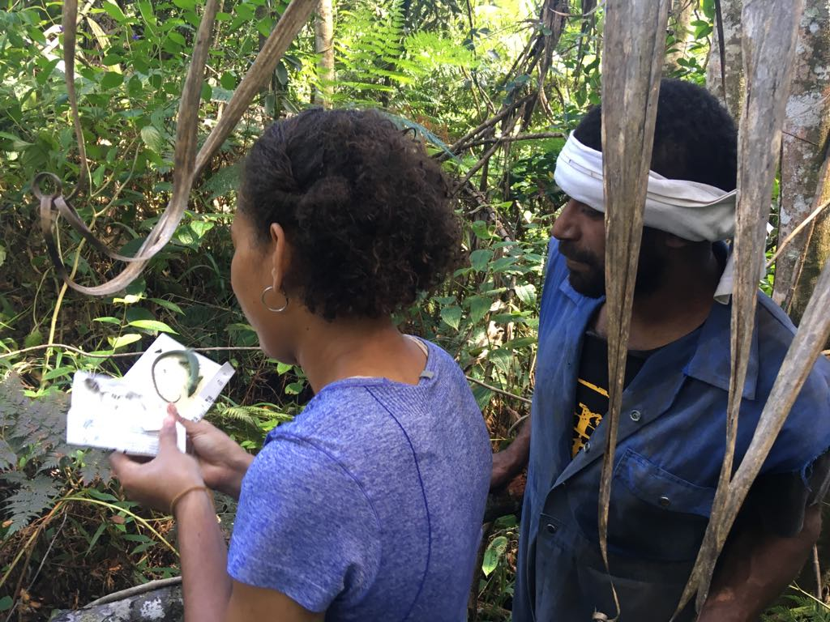The herpetofauna team with an endemic skink in the upper Tuva catchment.

**Photo Credit:** IAS, USP

**Activity 1.1.1.2:** A team from USP-IAS conducted CPUE and Shark and Ray studies in the Ba Delta with the hope of identifying and delineating culturally important and high or important biodiversity sites within the Vanua o Votua Qoliqoli for possible Marine Managed Areas.

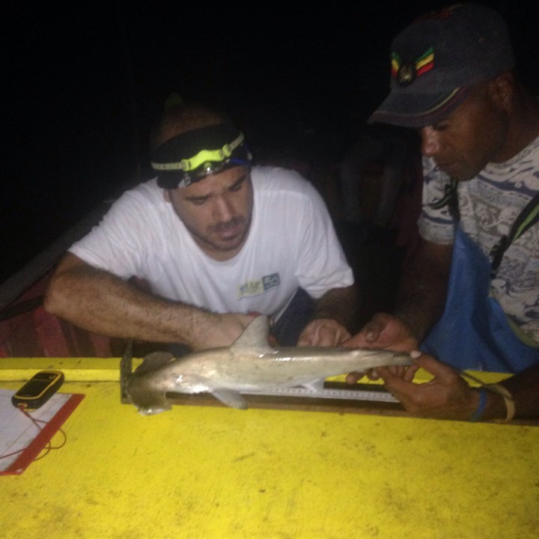

USP-IAS researcher and a local village guide carry out measurements on a juvenile hammerhead shark in the Ba Delta. Hammerhead sharks are listed on Appendix II of the Convention on International Trade in Endangered Species.

**Photo Credit:** IAS, USP

# CHALLENGES FACED AND CORRECTIVE ACTIONS TAKEN

*Challenges or difficulties encountered this quarter, like severe weather, lack of interest on stakeholder or beneficiaries’ part, elections, etc., and what USP-IAS has done/is doing to address the issue.*

Challenge 1: There were no challenges this quarter.

Recommendation: As above.

# USP-IAS ACTIVITIES AND MILESTONES FOR QUARTER 3 2019

*Planned activities for Quarter 3 2019 are listed here including those that will begin and continuing ones from the previous quarter. Do note that amounts requested below include a reimbursement for work carried out in Quarter 2 2019.*

**Activity 1.1.1.2 (continuation):** The joint GSR/R2R marine biological survey was postponed from Quarter 2 2019 to September or October 2019. Survey partners include the Ministry of Fisheries, WWF and USP-IAS. We’ve received confirmation from the Ministry of Fisheries that the survey will begin this Quarter from 23 September. Also to be completed in this Quarter is the shark and ray survey report which will identify and delineate a possible shark nursery sanctuary in the Ba Delta.

Milestone: Shark and Ray Survey Report

Budget Request: USD 48,565 (includes refund of USD 32,688.15)

**Activity 1.1.1.3 (continuation):** The Ba River freshwater mussel or kai survey will be completed in July and the report submitted by the end of August 2019. The phase two of fieldwork is scheduled for late July. The other report due in August is the Ba River water quality and sedimentation report which has been delayed as the pesticide analysis is awaiting results. Pesticides are an important perimeter for this R2R project.

Milestone: Ba River freshwater mussel and Ba River water quality and sedimentation reports.

Budget Request: USD 25,500 (includes refund of USD 12,961.85)

**Activity 1.1.1.4 (begin):** The joint GSR/R2R marine biological survey was postponed from Quarter 2 2019 to begin on 23 September and end on 14 October 2019 in Vunivia. Our team will only be involved with the Labasa aspect of this survey with logistics paid for this quarter. Survey partners include the Ministry of Fisheries, WWF and USP-IAS. Also to be completed in this Quarter are CPUE surveys in a number of user communities within the qoliqoli. USP-IAS will conduct a shark and ray baseline assessment report for the Labasa River mouth, an identified priority area for shark nursery at the gap analysis workshop in December 2018.

Milestone: CPUE Report, Shark and Ray Baseline Assessment (Report in Quarter 4 2019)

Budget Request: USD 58,000 (includes refund of USD 13,987.88)

**Activity 1.1.1.5 (begin):** The Labasa mangrove nekton survey, Labasa River invertebrate and vertebrate survey and Labasa River water quality and sedimentation field work will be carried out over Quarter 3 2019. The reconnaissance and logistics trip is planned for 12-14 August with the actual survey scheduled from 9-20 September. Limited lab work, analysis and data entry will begin in Quarter 3 but extend into October. The final reports are expected to be submitted at the end of November 2019.

Milestone: Completion of Labasa mangrove nekton survey, Labasa River invertebrate and vertebrate survey and Labasa River water quality and sedimentation field activities.

Budget Request: USD 46,140

**Activity 1.1.1.7 (ongoing):** The consultations with the eleven mataqali’s in Natewa-Tunuloa has been completed. The USP-IAS team will return to present the results of the consultations to all stakeholders in Savusavu in September through a workshop.

Milestone: Workshop Report.

Budget Request: USD 6,200

**Activity 1.1.2.11 (continuation):** The Tuva BioRap report will be submitted by the end of August 2019. It is in its drafting stage now before the lead scientist’s review.

Milestone: Tuva BioRap report.

Budget Request: USD 23,622.45 (includes refund of USD 8,022.45)

**Activity 2.1.1.14 (completed):** The identification of African tulip wastelands has been completed.

Milestone: Map of African tulip wastelands.

Budget Request: USD 31,190 (all refund)

**Activity 2.1.1.19 (begin):** This activity has had to be carried forward from Quarter 1 2019 as coordination is needed between the Ministry of Forests (responsible for Activities 2.1.1.15-2.1.1.18), Ministry of Agriculture, NTF and USP-IAS. A reforestation plan **needs to be agreed to** by the partners before implementation commences. USP-IAS had facilitated a first collaborative meeting in June, the outcome of which was a need for a second meeting to come up with steps to achieve the rehabilitation project in the Waidina catchment. We request the PMU to facilitate this second meeting as we will need clear directives and timelines as this Activity 2.1.1.19 is part of a sequence. USP-IAS’s partners for this Activity is the National Trust of Fiji (NTF).

Milestone: We hope for approval to implement this project with our partners from NTF.

Budget Request: Nil

**Activity 2.1.1.21 (continuation):** A meeting between the Ministry of Forests ITTO Project, MOE PMU, NGO Rep and USP-IAS agreed that the R2R project should adopt the ITTO’s six sites in the Rewa and Tailevu Provinces, beginning with sharing of project documents and an introduction of the R2R team to the ITTO communities. Work to be undertaken in Quarter 3 2019 include the stocking of seedlings at the Ministry of Forests distribution nurseries in the two provinces and the transplanting of *Rhizophora* seedlings in Nukui, Rewa and Nakalawaca, Tailevu. The Nukui transplanting will be used as an awareness event by the MOE and UNDP.

Milestone: Seedlings stored in distribution nurseries.

Budget Request: USD 30,200 (includes refund of USD 15,073.22)

**Activity 2.2.3.4 (Tuva) (continuation):** Phase two of the methodology workshop will be held in August 2019 before the sample plots baseline samples are collected and analyzed. The lab analysis and report will extend into Quarter 4 2019.

Milestone: Baseline data collected.

Budget Request: USD 21,300 (includes refund of USD 4,818.33)

**Activity 2.2.3.4 (Waidina) (continuation):** Phase two of the methodology workshop will be held in August 2019 before the sample plots baseline samples are collected and analyzed. The lab analysis and report will extend into Quarter 4 2019.

Milestone: Baseline data collected.

Budget Request: USD 26,000 (includes refund of USD 9,588.33)

**Activity 3.1.1.2 (continuation):** This activity has had to be carried over into Quarter 3 2019 as the lead scientist on this Activity had to attend to internal management changes.

Milestone: Gap analysis reports for Tuva, Vunivia and Tunuloa.

Budget Request: NA – full budget was received and has been fully utilized as of Quarter 1 2019. All expenses incurred from then until activity is complete will be USP-IAS’s in-kind contribution to the project.

**Activity 3.1.1.3 (continuation):** The Tuva, Vunivia and Tunuloa demographic, socio-economic and biophysical surveys will be conducted in Quarter 3 2019.

Milestone: Tuva, Vunivia and Tunuloa reports.

Budget Request: USD 52,550

**TOTAL AMOUNT REQUESTED FOR TRANCHE 3 TRANSFER = USD 369,267.45 (includes USD 128,330.21 as refund for Q2 2019 expenses)**